*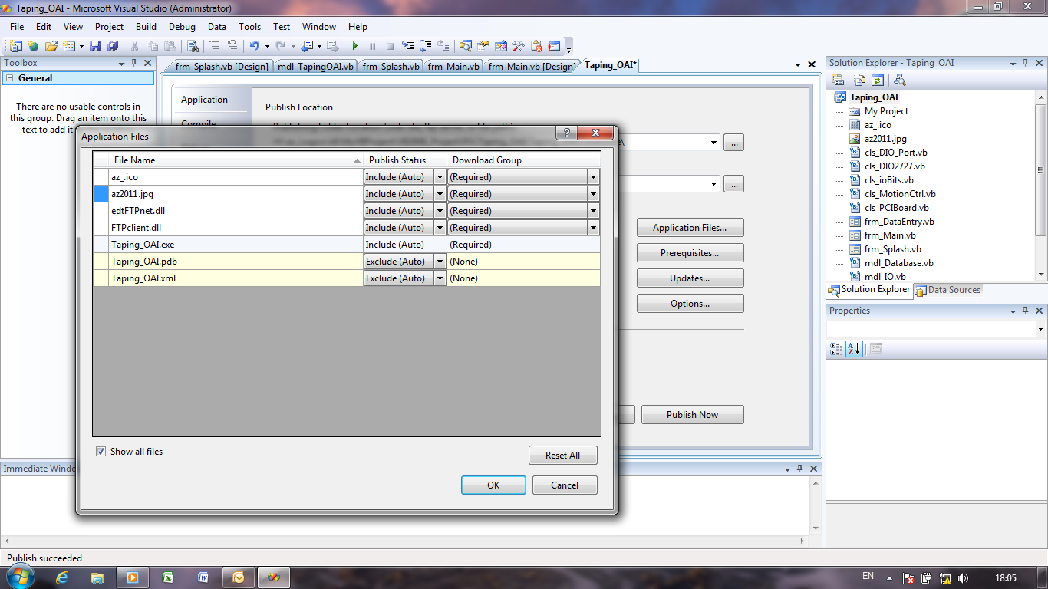Visual Studio 2008 – Click Once Software Deployment.*

Right-click here to add files

* Right-click on the project name to add custom files that is used by the application. Select “Copy Always” to copy the file to the Output path.
* By doing this, Visual Studio automatically add the application files in order to publish the entire application.

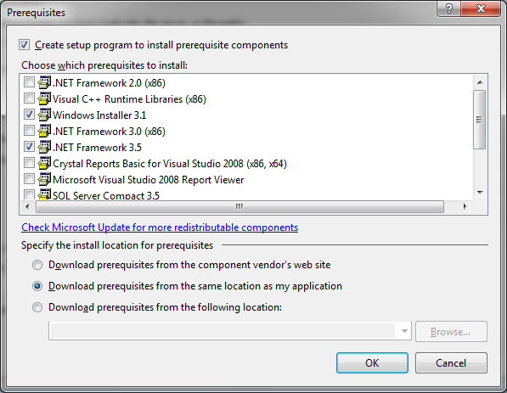Prerequisites are the software component that is required to redistribute the specific piece of software. Without these components, the setup application will not be able to run.

Choose as the figure shown if the software is deploy through CD or from the computer file system.

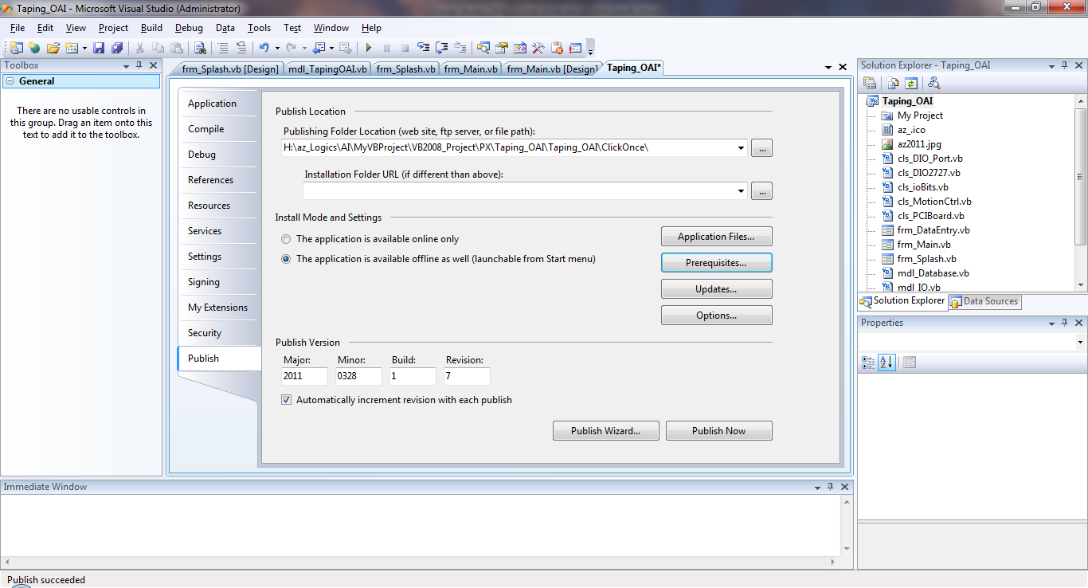Click once used this number to identified the publish version of a software. Select “Automatically increment revision with each publish” will automatically increase the number.

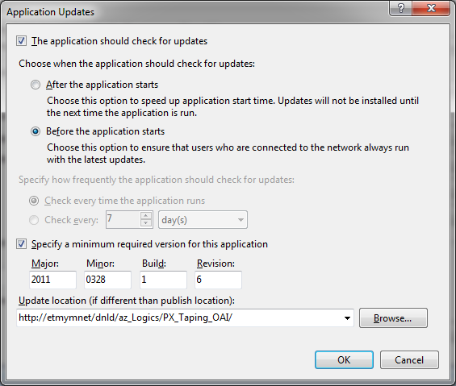

Checked this item in order to let the application check for updates every time it is being launched.

Specify the minimum required version of the software together the path hosted by the IIS for the new release as shown in the figure.

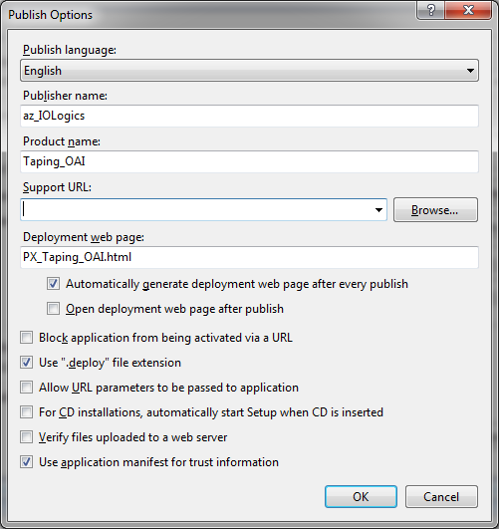

The last part of the Click Once setting is the Publish Option. Fill in the appropriate information as the example given in the above.